Pinging the VM via Kali

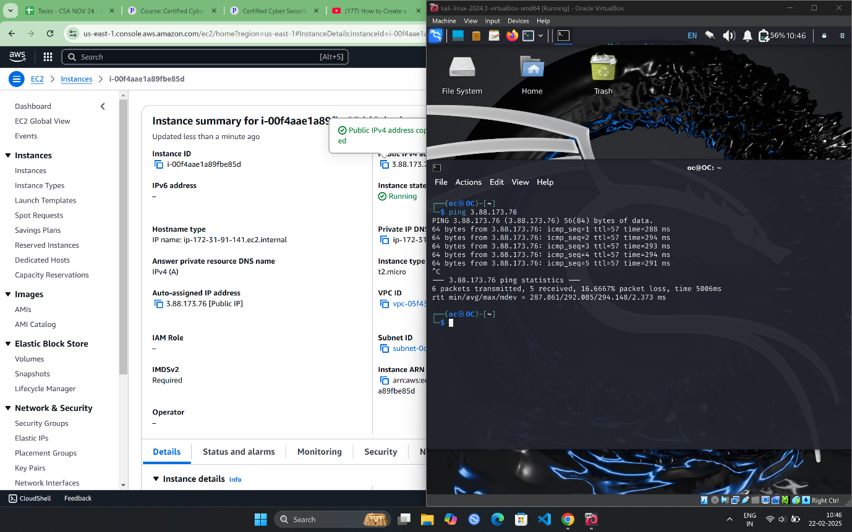

Login VM Via SSH

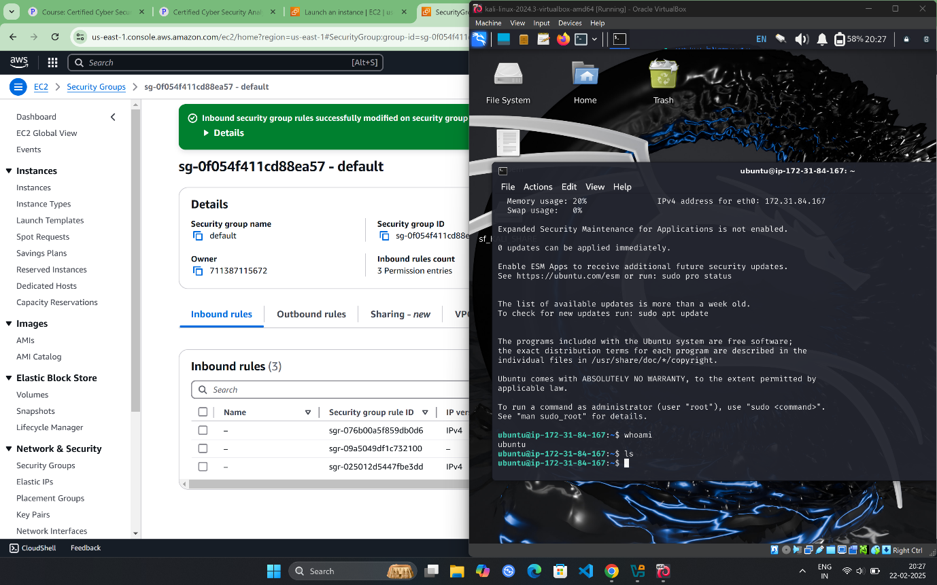

And then tried to ping my public IP From the AWS VM but it didn’t give any response

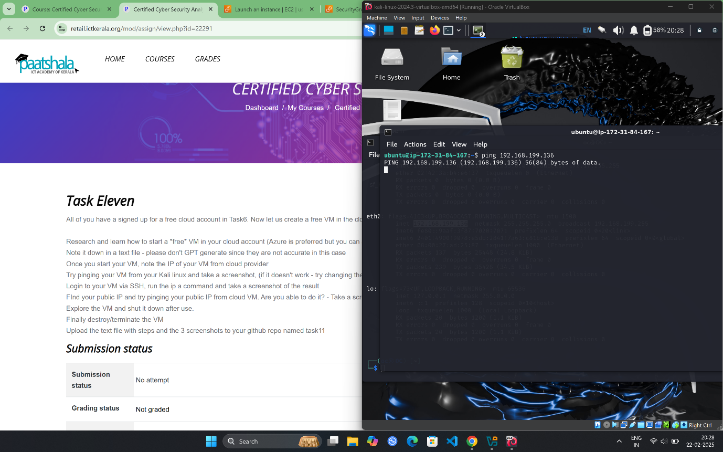

So I jus Try to ping the Kali from my windows to make sure that I entered the correct address

